Loading Data Into HBase Using PIG Scripts.

Implement the concept given in below blog link and share the complete steps along with

screenshots.

https://acadgild.com/blog/loading-data-into-hbase-using-pig-scripts/

1. Make sure hbase jars in pig classpath

PIG_CLASSPATH=/home/hadoop/HADOOP/hbase-0.98.4-hadoop2/lib/hbase-server-0.98.4-hadoop2:/home/hadoop/HADOOP/hbase-0.98.4-hadoop2/lib/hbase-*.jar;

1. Create table in Hbase

create 'studentAcad', 'student_data'

1. Load data in pid from hdfs location

rawD= LOAD '/niki/student.txt' using PigStorage(',') as (studentName:chararray,sector:chararray,DOB:chararray,qualification:chararray,score:int,state:chararray,randomName:chararray);

1. Store data from pig to hbase

STORE rawD into 'hbase://studentAcad' using org.apache.pig.backend.hadoop.hbase.HBaseStorage('student_data:studentName,student_data:sector,student_data:DOB,student_data:qualification,student_data:score,student_data:state,student_data:randomName');

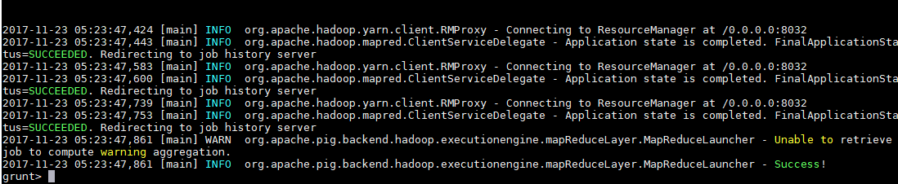

scan 'studentAcad'

